**Karachi:**

Turtle Beach

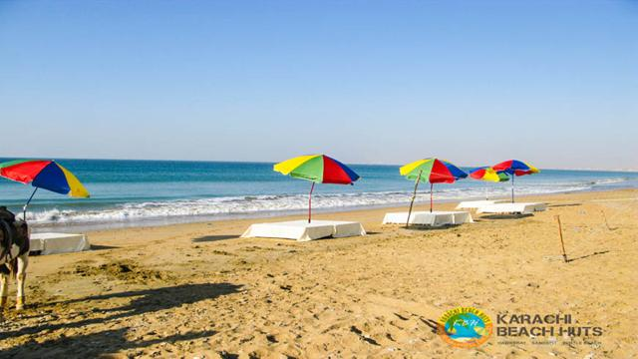

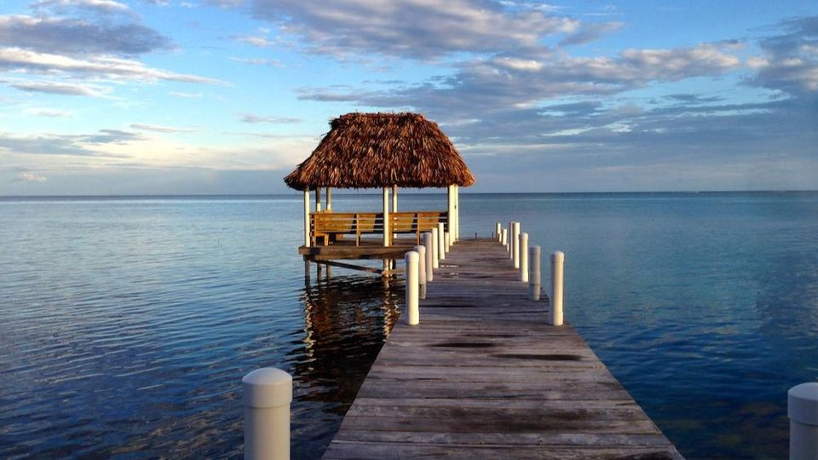

Turtle beach is very famous tourist spot and picnic place in karachi.its a naturally sandy beach where no rocks and reefs. its located between hawksbay and sandspit. In summers, rare species of Green and Olive Ridley Turtles come to lay eggs in the Southwest beaches of Karachi, specially to the Sandspit Beach and the Hawksbay Beach. The name "Sandspit" itself refers to pits made by Turtles to burry eggs. These pits can be obsereved on the beachside during summer months. During the nesting period, Lucky ones can see these Turtles creeping in and out of the sea mostly after the sunset. These turtles form tractor like tracks, as shown in the photographs, visible all around alongside the beach. World Wildlife Fund (WWF) has also set-up a Wetland Center at Sandspit Beach to dissiminate awareness about turtle conservation methods. These beaches also host various other marine species, to name the few are Algae, Snails, and Crabs.